Java Constructor Practical 04-10-2023

Three Methods to give value to variables.

**package** com.traning.org;

**import** java.io.BufferedReader;

**import** java.io.IOException;

**import** java.io.InputStreamReader;

**import** java.util.Scanner;

**import** javax.swing.JOptionPane;

**public** **class** Complex {

**private** **int** real;

**private** **int** imag;

//Default constructor

**public** Complex() {

System.***out***.println("Default constructor of Complex is called");

real=0;

imag=0;

}

//Parameterized constructor

**public** Complex(**int** real,**int** imag) {

System.***out***.println("Parameteriezed constructor of Complex is called");

real=0;

imag=0;

}

**public** **void** showComplexValues() {

System.***out***.println("Complex values are "+real+" "+imag);

}

**public** **void** acceptCompexValues() **throws** NumberFormatException, IOException {

// First Method

/*

BufferedReader input =new BufferedReader(new InputStreamReader(System.in));

System.out.println("Enter the values for real");

this.real=Integer.parseInt(input.readLine());

System.out.println("Enter the values for imag");

this.imag=Integer.parseInt(input.readLine());

*/

// Second Method New Way

/*

Scanner scn = new Scanner(System.in);

System.out.println("Enter the values for real: ");

this.real = scn.nextInt();

System.out.println("Enter the values for imag: ");

this.imag = scn.nextInt();

System.out.println(real+","+imag);

scn.close();

*/

//Third method

**this**.real=Integer.*parseInt*(JOptionPane.*showInputDialog*("Enter first value"));

**this**.imag=Integer.*parseInt*(JOptionPane.*showInputDialog*("Emter second value"));

JOptionPane.*showMessageDialog*(**null**,"Values are"+**this**.real+" "+**this**.imag);

}

**public** **static** **void** main(String[] args) **throws** IOException {

Complex c1=**new** Complex();

c1.acceptCompexValues();

c1.showComplexValues();

// Complex c2=new Complex(100,200);

// c2.showComplexValues();

// System.out.println(c1);

// for (int i = 0; i < 10; i++ ) {

// System.out.println("I"+i);

// }

}

}

Third Method Output:

One Java file used values other Java file class default and parameterized constructor:

**Employee.java**

**package** com.training.org;

**public** **class** Employee {

**private** **int** empId;

**private** String empName;

**private** **double** salary;

**public** Employee() {

System.***out***.println("Default constructor of Employee is called");

**this**.empId=22;

**this**.empName="Nitin";

**this**.salary=100;

}

**public** Employee(**int** empId, String empName, **double** salary) {

System.***out***.println("Parameterized Constructor of Employee is called");

**this**.empId = empId;

**this**.empName = empName;

**this**.salary = salary;

}

**public** String toString() {

**return** "Employee Details are ID: "+empId+", Employee Name is "+empName+"and Salary is"+salary;

}

}

**XYZOrg.java**

**package** com.training.org;

**public** **class** XYZOrg {

**public** **static** **void** main(String[] args) {

Employee e1=**new** Employee();

System.***out***.println(e1);

Employee e2=**new** Employee(101,"Eshan",10000);

System.***out***.println(e2);

}

}

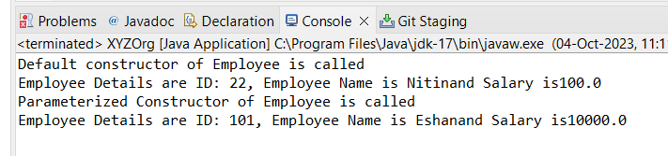

**Add Extra code in XYZOrg.java file**

**package** com.training.org;

**import** java.util.ArrayList;

**import** java.util.Scanner;

**public** **class** XYZOrg {

**public** **static** **void** main(String[] args) {

ArrayList<Employee> empList=**new** ArrayList<Employee>();

Scanner input=**new** Scanner(System.***in***);

**char** ch;

**do** {

System.***out***.println("1] Add new record \n2] Display records\n\n ");

**int** choice=input.nextInt();

**switch**(choice) {

**case** 1:

System.***out***.println("Enter ID");

**int** id=input.nextInt();

System.***out***.println("Enter name");

String name=input.next();

System.***out***.println("Enter Salary");

**double** sal=input.nextDouble();

empList.add(**new** Employee(id,name,sal));

System.***out***.println("Record is added successfully....");

**break**;

**case** 2:

System.***out***.println("***** Employee records are *********");

**for** (Employee emp : empList) {

System.***out***.println(emp);

}

**break**;

**default**:

System.***out***.println("Invalid Choice....");

**break**;

}

System.***out***.println("Do you want to continuee....");

ch=input.next().charAt(0);

}**while**(ch=='y'||ch=='Y');

System.***out***.println("I'm done");

}

}

**Enter 1 >> and Enter values one by one…**

**Display record Enter 2 >>**

**Add 3rd and 4th Switch Case:**

Add 3rd switch case to delete record.

Add 4th switch case is Replace/Update record.

Add nested switch case for name and salary changes.

**Employee.java**

**package** com.training.org;

**public** **class** Employee {

**private** **int** empId;

**private** String empName;

**private** **double** salary;

**public** Employee() {

System.***out***.println("Default constructor of Employee is called");

**this**.empId=0;

**this**.empName="";

**this**.salary=0;

}

**public** Employee(**int** empId,String empName,**double** salary) {

System.***out***.println("Parameterised constructor of Employee is called");

**this**.empId=empId;

**this**.empName=empName;

**this**.salary=salary;

}

**public** String getEmpName() {

**return** empName;

}

**public** **void** setEmpName(String name) {

**this**.empName=name;

}

**public** **double** getSalary() {

**return** salary;

}

**public** **void** setSalary(**double** salary) {

**this**.salary=salary;

}

**public** String toString() {

**return** " | "+**this**.empId+" | "+**this**.empName+" | "+**this**.salary;

}

}

**XYZOrg.java**

package com.training.org;

import java.util.ArrayList;

import java.util.Scanner;

public class XYZOrg {

public static void main(String[] args) {

ArrayList<Employee> empList=new ArrayList<Employee>();

Scanner input=new Scanner(System.in);

char ch;

do {

System.***out***.println("1] Add new record \n2] Display records\n3] Delete Records\n4] Update Records\n\n ");

int choice=input.nextInt();

int flag=0;

switch(choice) {

case 1:

System.out.println("Enter ID");

int id=input.nextInt();

System.out.println("Enter name");

String name=input.next();

System.out.println("Enter Salary");

double sal=input.nextDouble();

empList.add(new Employee(id,name,sal));

System.out.println("Record is added successfully....");

break;

case 2:

System.out.println("***** Employee records are *********");

for (Employee emp : empList) {

System.out.println(emp);

}

break;

case 3:

System.out.println("Enter the name to delete");

String nm=input.next();

for(int i=0; i<empList.size(); i++) {

if(empList.get(i).getEmpName().equals(nm)) {

empList.remove(i);

System.out.println("Record is deleted suceefully");

flag=1;

break;

}

}

if(flag==0) {

System.out.println("Record is not available....");

}

break;

case 4:

System.out.println("a] Update name \nb] Update salary\n\n");

int choice1=input.nextInt();

switch(choice) {

case 1:

System.out.println("Enter the old name to replace");

String nmOld=input.next();

for(int i=0; i<empList.size(); i++) {

if(empList.get(i).getEmpName().equals(nmOld)) {

System.out.println("Enter new name to replace with "+nmOld+"name");

String nmNew=input.next();

empList.get(i).setEmpName(nmNew);

System.out.println("Update the name successfully....");

flag=1;

break;

}

}

int flag1;

if(flag1==0)

System.out.println("Record not found for deletion....");

break;

case 2:

System.out.println("Provide yearly increment for employee with condition");

System.out.println("Enter the salary for condition...");

int checkSal=input.nextInt();

System.out.println("Enter increment percentage");

double incrementPer=input.nextDouble();

for(int i=0; i<empList.size(); i++) {

if(empList.get(i).getSalary()<checkSal) {

empList.get(i).setSalary(empList.get(i).getSalary()*(incrementPer/100+1));

}

}

}

break;

default:

System.out.println("Invalid Choice....");

break;

}

System.out.println("Do you want to continuee....");

ch=input.next().charAt(0);

}while(ch=='y'||ch=='Y');

System.out.println("I'm done");

}

}

**OUTPUT**

**Add records and delete record.**

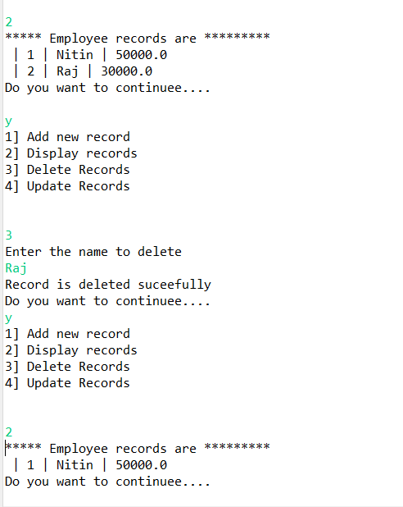

**‘**

**Update records values:**



